
Republic of the Philippines District VI, Quezon City
Barangay Culiat
Office of the Barangay Chairman

CERTIFICATE OF RESIDENCY


TO WHOM IT MAY CONCERN:

This is to certify that MS. RACHELL ANN FESALVO LARGUEZA, born on March 17, 1991, Single, is a bonafide resident of 31 Purok 4B Luzon Avenue, Barangay Culiat, Quezon City since January 2008 up to present.

The undersigned has certified that after a reasonable inquiry, I have verified the authenticity of barangay residency showing that the applicant has been residing in the barangay for at least six (6) months prior to the application of this Affidavit of Residency.

This certification is issued upon the request of the above-named person as a supporting document for QC ID Application.

Issued this 19th day of November 2025, at Barangay Hall, Barangay Culiat, District 6, Quezon City.

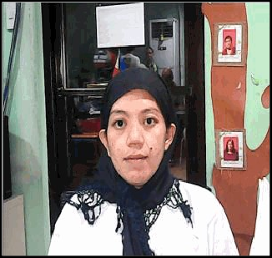

APPLICANT'S PHOTO APPLICANT'S THUMBMARK


Issued at : BARANGAY CULIAT HALL
Issued on : November 19, 2025
Valid until: May 19, 2026

. This certification document is not valid without Official Barangay Dry Seal, Punong Barangay Signature/Stamp.
. Officials and applicants who will submit false certification or documents shall be held liable for administrative/criminal liabilities.

Prepared by : Nymfa Reference no : RN2025-4710 Document file : DFN2025-4707

